**Technical University of Sofia**

**Film Library Application**

Faculty: FDIBA

Discipline: Programming 2

Professor: Mariana Goranova

Student: Kalin Petrov

№ 201213035

Date: 23.06.2016

1. Application description

The application is a Film Library program. It enables the users, who are registered in the user’s database, to search and view different movies from a movies database, depending on what they are looking for. There is a short registration, where the user must enter a valid username, password and email. Once that is done, the user can sign in and use the application and have access to the movie’s database. Movies can be search through their name, director or actors. The movies can also be sorted by genre, popularity or date. Users that have an admin status can also change and edit the databases, that are used in this application.

2. Forms used in the application:

* Buttons-help the user to manage and control the application
* Labels-provide descriptive text
* ComboBox-lets the user choose from different options
* TextBoxes-enable the user to enter text
* PictureBoxes-display an image
* Panel-enables the grouping of controls
* DataGridView-displays rows and columns of data in a grid

3. Other used features:

* .NET Entity Framework and ADO.NET
* SQL Server
* SQL Queries
* Regular expressions

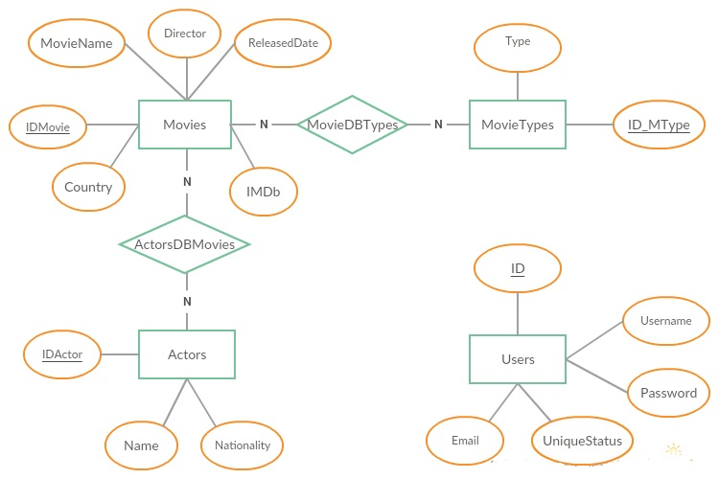4. Entity Relationship Diagram

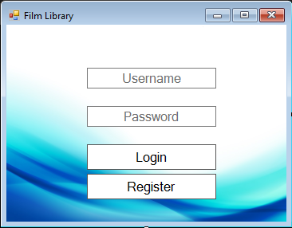5. Code description:

usernameBox

passwordBox

loginButton

registerButton

**private** void usernameBox_Enter**(object** sender**,** EventArgs e**)**

**{**//when the username box is entered,clear the text inside

**if** **(**usernameBox**.**Text**==**"Username"**)**

**{**

usernameBox**.**Text **=** ""**;**

**}**

**}**

**private** void usernameBox_Leave**(object** sender**,** EventArgs e**)**

**{**//when the username box is left,enter "Username" inside and change text color

**if** **(**usernameBox**.**Text **==** ""**)**

**{**

usernameBox**.**Text **=** "Username"**;**

usernameBox**.**ForeColor **=** Color**.**Gray**;**

**}**

**}**

**private** void passwordBox_Leave**(object** sender**,** EventArgs e**)**

**{**//when the username box is left,enter "Password" inside and change text color

**if** **(**passwordBox**.**Text **==** ""**)**

**{**

passwordBox**.**PasswordChar **=** '\0'**;**

passwordBox**.**Text **=** "Password"**;**

passwordBox**.**ForeColor **=** Color**.**Gray**;**

**}**

**}**

**private** void passwordBox_Enter**(object** sender**,** EventArgs e**)**

**{**//when the password box is entered,clear the text inside

**if** **(**passwordBox**.**Text **==** "Password"**)**

**{**

passwordBox**.**Text **=** ""**;**

passwordBox**.**PasswordChar **=** '*'**;**

**}**

**}**

Thread th**;**

bool foundUser **=** **false;**

UsersDBEntities ef **=** **new** UsersDBEntities**();**

**private** void registerButton_Click**(object** sender**,** EventArgs e**)**

**{**//when register button is clicked create new thread

//and open Registration Form and close current

**this.**Close**();**

th **=** **new** Thread**(**OpenNewRegisterForm**);**

th**.**SetApartmentState**(**ApartmentState**.**STA**);**

th**.**Start**();**

**}**

**private** void OpenNewRegisterForm**()**

**{** //and open Register Form

Application**.**Run**(new** RegisterForm**());**

**}**

**private** void loginButton_Click**(object** sender**,** EventArgs e**)** //when loginButton is clicked

**{**

**foreach** **(**var user **in** ef**.**Users**)** // go through the Users Table

**{**

**if** **(**user**.**Username**.**Equals**(**usernameBox**.**Text**)** **&&** user**.**Password**.**Equals**(**passwordBox**.**Text**))**

**{** //Search for user with Username and Password equal to the input in the textboxes

MessageBox**.**Show**(**"Successful Login"**);** // if the search is successful show message

**if** **(**user**.**UniqueStatus**.**Trim**().**ToString**().**Equals**(**"admin"**))** //check user Status

**{** //if the user has admin status,create new thread and open AdminFormChoice Form and close current

foundUser **=** **true;**

**this.**Close**();**

th **=** **new** Thread**(**OpenNewAdminFormChoice**);**

th**.**SetApartmentState**(**ApartmentState**.**STA**);**

th**.**Start**();**

**break;**

**}**

//create new thread and open IntroForm Form and close current

foundUser **=** **true;**

**this.**Close**();**

th **=** **new** Thread**(**OpenNewIntroForm**);**

th**.**SetApartmentState**(**ApartmentState**.**STA**);**

th**.**Start**();**

**break;**

**}**

**}**

**if** **(!**foundUser**)** // if there is no match, show message

**{**

MessageBox**.**Show**(**"Unsuccessful Login"**);**

**}**

**}**

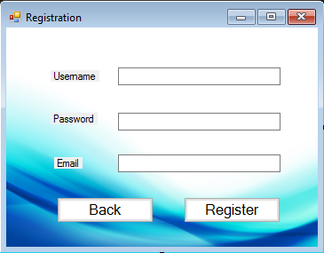

usertextBox1

passtextBox2

mailtextBox3

button1, button2

using System.Text.RegularExpressions;

using System.Threading;

UsersDBEntities ef= new UsersDBEntities();

Thread th;

bool validData = true;

**private** void button1_Click**(object** sender**,** EventArgs e**)**

**{**////when Back button is clicked create new thread and open Login Form and close current

**this.**Close**();**

th **=** **new** Thread**(**OpenNewLoginForm**);**

th**.**SetApartmentState**(**ApartmentState**.**STA**);**

th**.**Start**();**

**}**

**private** void OpenNewLoginForm**()**

**{**//open Login form

Application**.**Run**(new** LoginForm**());**

**}**

using System.Text.RegularExpressions;

using System.Threading;

**private** void button2_Click**(object** sender**,** EventArgs e**)**

**{**//When register button is clicked

Regex regex **=** **new** Regex**(**@"^([\w\.\-]+)@([\w\-]+)((\.(\w){2,3})+)$"**);**

Match match **=** regex**.**Match**(**mailtextBox3**.**Text**);**

**if** **(**match**.**Success **&&** **!**usertextBox1**.**Text**.**Contains**(**" "**)** **&&** **!**passtextBox2**.**Text**.**Contains**(**" "**))**

**{**//check if the entered email,username and password are valid

**foreach** **(**var myUser **in** ef**.**Users**)**

**{**//go through the Users Table

**if** **(**myUser**.**Username**.**Equals**(**usertextBox1**.**Text**))**

**{**//check if the Username is taken

MessageBox**.**Show**(**"The Username is taken"**);**

validData **=** **false;**

**break;**

**}**

**if** **(**myUser**.**Email**.**Equals**(**mailtextBox3**.**Text**))**

**{**///check if the Username is taken

MessageBox**.**Show**(**"The Email is taken"**);**

validData **=** **false;**

**break;**

**}**

**}**

**if** **(**validData **==true)**

**{**//if all the input is valid and not taken,add the user information in the Users Table

//(create account)

Users user **=** **new** Users**();**

user**.**Username **=** usertextBox1**.**Text**;**

user**.**Password **=** passtextBox2**.**Text**;**

user**.**Email **=** mailtextBox3**.**Text**;**

user**.**UniqueStatus **=** "user"**;**

ef**.**Users**.**Add**(**user**);**

ef**.**SaveChanges**();**

MessageBox**.**Show**(**"Successful Register"**);**

**}**

**}**

**else**

**{**//if the input isn't valid

MessageBox**.**Show**(**"Invalid Input"**);**

**}**

**}**

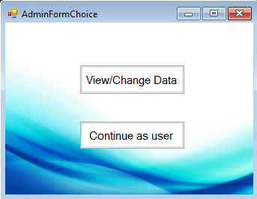

Button1

Button2

**private** void button2_Click**(object** sender**,** EventArgs e**)**

**{**// When Continue as user button gets clicked

//create new thread and open AdminAlterTablesForm Form and close current

**this.**Close**();**

th **=** **new** Thread**(**OpenNewIntroForm**);**

th**.**SetApartmentState**(**ApartmentState**.**STA**);**

th**.**Start**();**

**}**

**private** void OpenNewIntroForm**()**

**{**

Application**.**Run**(new** IntroForm**());**

**}**

**private** void button1_Click**(object** sender**,** EventArgs e**)**

**{**// When View/Change Data button gets clicked

//create new thread and open IntroForm Form and close current

**this.**Close**();**

th **=** **new** Thread**(**OpenNewAdminAlterTablesForm**);**

th**.**SetApartmentState**(**ApartmentState**.**STA**);**

th**.**Start**();**

**}**

**private** void OpenNewAdminAlterTablesForm**()**

**{**

Application**.**Run**(new** AdminAlterTablesForm**());**

**}**

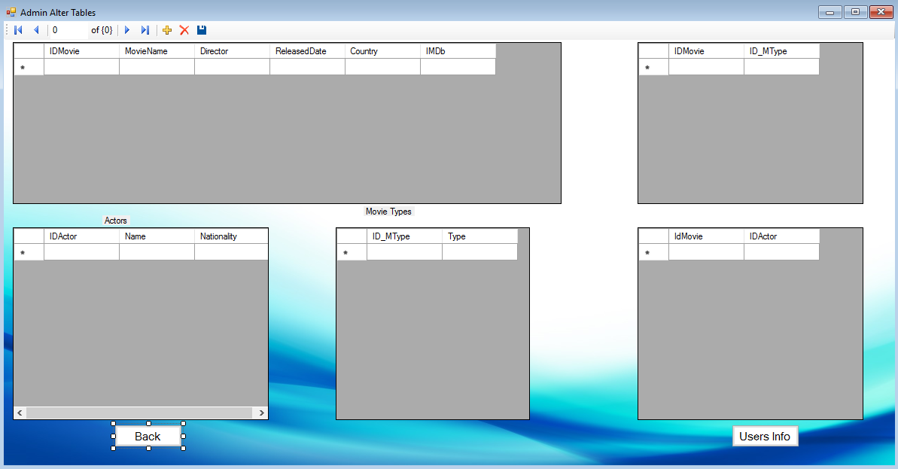 Button1 Button2

**private** void button1_Click**(object** sender**,** EventArgs e**)**//Back Button

**{**// When Back button gets clicked

//create new thread and open AdminFormChoice Form and close current

**this.**Close**();**

th **=** **new** Thread**(**OpenNewLoginForm**);**

th**.**SetApartmentState**(**ApartmentState**.**STA**);**

th**.**Start**();**

**}**

**private** void OpenNewLoginForm**()**

**{**

Application**.**Run**(new** AdminFormChoice**());**

**}**

**private** void button2_Click**(object** sender**,** EventArgs e**)** //Button Users Info

**{**// When Users info button gets clicked

//create new thread and open AdminUserInfo Form and close current

**this.**Close**();**

th **=** **new** Thread**(**OpenNewAdminUserInfoForm**);**

th**.**SetApartmentState**(**ApartmentState**.**STA**);**

th**.**Start**();**

**}**

**private** void OpenNewAdminUserInfoForm**()**

**{**

Application**.**Run**(new** AdminUserInfo**());**

**}**

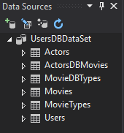 Data Source from the Database

**private** void AdminAlterTablesForm_Load**(object** sender**,** EventArgs e**)**

**{**

// TODO: This line of code loads data into the 'usersDBDataSet.MovieTypes' table. You can move, or remove it, as needed.

**this.**movieTypesTableAdapter**.**Fill**(this.**usersDBDataSet**.**MovieTypes**);**

// TODO: This line of code loads data into the 'usersDBDataSet.Actors' table. You can move, or remove it, as needed.

**this.**actorsTableAdapter**.**Fill**(this.**usersDBDataSet**.**Actors**);**

// TODO: This line of code loads data into the 'usersDBDataSet.ActorsDBMovies' table. You can move, or remove it, as needed.

**this.**actorsDBMoviesTableAdapter**.**Fill**(this.**usersDBDataSet**.**ActorsDBMovies**);**

// TODO: This line of code loads data into the 'usersDBDataSet.MovieDBTypes' table. You can move, or remove it, as needed.

**this.**movieDBTypesTableAdapter**.**Fill**(this.**usersDBDataSet**.**MovieDBTypes**);**

// TODO: This line of code loads data into the 'usersDBDataSet.Movies' table. You can move, or remove it, as needed.

**this.**moviesTableAdapter**.**Fill**(this.**usersDBDataSet**.**Movies**);**

**}**

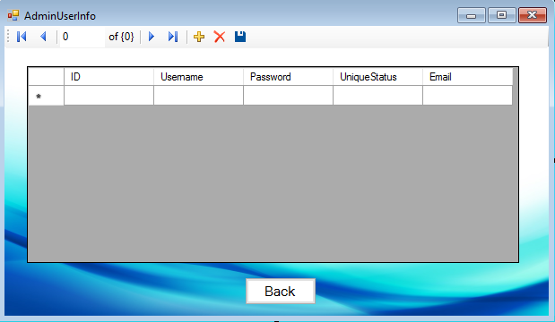

backButton

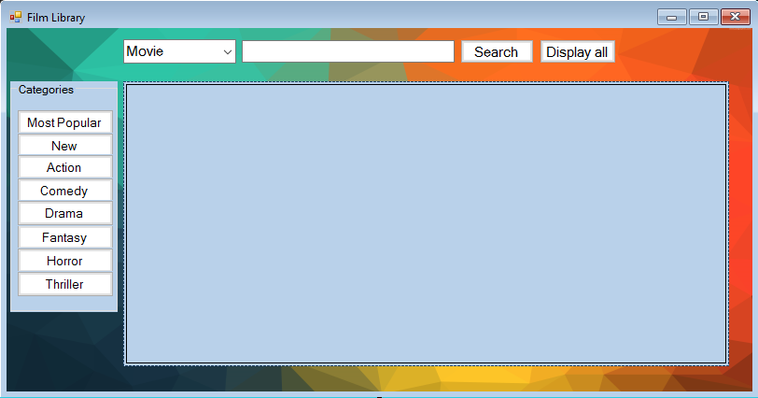

**private** void usersBindingNavigatorSaveItem_Click**(object** sender**,** EventArgs e**)**

**{**

**this.**Validate**();**

**this.**usersBindingSource**.**EndEdit**();**

**this.**tableAdapterManager**.**UpdateAll**(this.**usersDBDataSet**);**

**}**

**private** void AdminUserInfo_Load**(object** sender**,** EventArgs e**)**

**{**

// TODO: This line of code loads data into the 'usersDBDataSet.Users' table. You can move, or remove it, as needed.

**this.**usersTableAdapter**.**Fill**(this.**usersDBDataSet**.**Users**);**

**}**

**private** void button1_Click**(object** sender**,** EventArgs e**)**

**{**// When Back button gets clicked

//create new thread and open AdminAlterTablesForm Form and close current

**this.**Close**();**

th **=** **new** Thread**(**OpenNewAdminAlterTablesForm**);**

th**.**SetApartmentState**(**ApartmentState**.**STA**);**

th**.**Start**();**

**}**

**private** void OpenNewAdminAlterTablesForm**()**

**{**

Application**.**Run**(new** AdminAlterTablesForm**());**

**}**

searchBox

searchButton

showAllButton

comboBox1

MostPopularButton

button3

ActionMovieButton

ComedyMovieButton

DramaMovieButton

FantasyMovieButton

HorrorMovieButton

ThrillerMovieButton

dataGridView1

//SQL connection through connection string

SqlConnection conn **=** **new** SqlConnection**(**"Data Source=DESKTOP-KBGVJ8B;Initial Catalog=UsersDB;Integrated Security=True;Pooling=False"**);**

**public** IntroForm**()**

**{**

InitializeComponent**();**

**}**

**private** void button1_Click**(object** sender**,** EventArgs e**)**//searchButton_Click

**{** //creating new empty temporary table

DataTable dt **=** **new** DataTable**();**

**if** **(**comboBox1**.**Text**.**Equals**(**"Movie"**))**

**{** //when the comboBox choice is Movie

//execute query to find the movie that is written in the searchBox and return all information about it

SqlDataAdapter SDA **=** **new** SqlDataAdapter**(**"SELECT Movies.MovieName,Movies.Director,Movies.ReleasedDate,Movies.Country,Movies.IMDb FROM Movies WHERE MovieName='" **+** searchBox**.**Text**.**ToString**()** **+** "'"**,** conn**);**

SDA**.**Fill**(**dt**);** //fill the new table

dataGridView1**.**DataSource **=** dt**;** //show the table

**}**

**else** **if** **(**comboBox1**.**Text**.**Equals**(**"Director"**))**

**{** //when the comboBox choice is Director

//execute query to find the director that is written in the searchBox and return all his movie and information

SqlDataAdapter SDA **=** **new** SqlDataAdapter**(**"SELECT Movies.MovieName,Movies.Director,Movies.ReleasedDate,Movies.Country,Movies.IMDb FROM Movies WHERE Director='" **+** searchBox**.**Text**.**ToString**()** **+** "'"**,** conn**);**

SDA**.**Fill**(**dt**);**

dataGridView1**.**DataSource **=** dt**;**

**}**

**else**

**{**//when the comboBox choice is Actor

//execute query to find the Actor that is written in the searchBox and return all his movie and information

SqlDataAdapter SDA **=** **new** SqlDataAdapter**(**"SELECT Movies.MovieName,Movies.Director,Movies.ReleasedDate,Movies.Country,Movies.IMDb ,Actors.Name FROM Movies ,Actors ,ActorsDBMovies WHERE Movies.IDMovie=ActorsDBMovies.IdMovie AND ActorsDBMovies.IDActor=Actors.IDActor AND Actors.Name='" **+** searchBox**.**Text**.**ToString**()** **+** "'"**,** conn**);**

SDA**.**Fill**(**dt**);**

dataGridView1**.**DataSource **=** dt**;**

**}**

**}**

**private** void MostPopularButton_Click**(object** sender**,** EventArgs e**)**

**{**//when Most Popular button gets clicked,creating new empty temporary table

//execute query that finds all movies that are action type

DataTable dt **=** **new** DataTable**();**

SqlDataAdapter SDA **=** **new** SqlDataAdapter**(**"SELECT Movies.MovieName,Movies.Director,Movies.ReleasedDate,Movies.Country,Movies.IMDb FROM Movies WHERE MovieName in ('Warcraft','Star Wars','Zootopia','Now You See Me 2','Angry Birds','The Last King','London Has Fallen')"**,** conn**);**

SDA**.**Fill**(**dt**);**

dataGridView1**.**DataSource **=** dt**;**

**}**

**private** void showAllButton_Click**(object** sender**,** EventArgs e**)**

**{**//when Display all button gets clicked,creating new empty temporary table

//execute query that shows information about all the movies in the database

DataTable dt **=** **new** DataTable**();**

SqlDataAdapter SDA **=** **new** SqlDataAdapter**(**"SELECT Movies.MovieName,Movies.Director,Movies.ReleasedDate,Movies.Country,Movies.IMDb FROM Movies"**,** conn**);**

SDA**.**Fill**(**dt**);**

dataGridView1**.**DataSource **=** dt**;**

**}**

**private** void button3_Click**(object** sender**,** EventArgs e**)**//New Movies

**{**

//when New button gets clicked,creating new empty temporary table

//execute query that finds all movies that have a Release Date that belongs in the past month

DataTable dt **=** **new** DataTable**();**

DateTime date **=** DateTime**.**Now**.**AddMonths**(-**1**);**

SqlCommand cc **=** **new** SqlCommand**(**

"SELECT Movies.MovieName,Movies.Director,Movies.ReleasedDate,Movies.Country,Movies.IMDb FROM Movies WHERE ReleasedDate>=@date"**,** conn**);**

cc**.**Parameters**.**AddWithValue**(**"@date"**,** date**);**

SqlDataAdapter SDA **=** **new** SqlDataAdapter**(**cc**);**

SDA**.**Fill**(**dt**);**

dataGridView1**.**DataSource **=** dt**;**

**}**

**private** void HorrorMovieButton_Click**(object** sender**,** EventArgs e**)**

**{**//when Horror button gets clicked,creating new empty temporary table

//execute query that shows all movies that are horror

DataTable dt **=** **new** DataTable**();**

SqlDataAdapter SDA **=** **new** SqlDataAdapter**(**"SELECT Movies.MovieName,Movies.Director,Movies.ReleasedDate,Movies.Country,Movies.IMDb ,MovieTypes.Type FROM Movies ,MovieTypes ,MovieDBTypes WHERE Movies.IDMovie=MovieDBTypes.IDMovie AND MovieDBTypes.ID_MType=MovieTypes.ID_MType AND MovieTypes.Type='Horror'"**,** conn**);**

SDA**.**Fill**(**dt**);**

dataGridView1**.**DataSource **=** dt**;**

**}**

**private** void ActionMovieButton_Click**(object** sender**,** EventArgs e**)**

**{**//when Action button gets clicked,creating new empty temporary table

//execute query that shows all movies that are action

DataTable dt **=** **new** DataTable**();**

SqlDataAdapter SDA **=** **new** SqlDataAdapter**(**"SELECT Movies.MovieName,Movies.Director,Movies.ReleasedDate,Movies.Country,Movies.IMDb ,MovieTypes.Type FROM Movies ,MovieTypes ,MovieDBTypes WHERE Movies.IDMovie=MovieDBTypes.IDMovie AND MovieDBTypes.ID_MType=MovieTypes.ID_MType AND MovieTypes.Type='Action'"**,** conn**);**

SDA**.**Fill**(**dt**);**

dataGridView1**.**DataSource **=** dt**;**

**}**

**private** void ComedyMovieButton_Click**(object** sender**,** EventArgs e**)**

**{**

//when Comedy button gets clicked,creating new empty temporary table

//execute query that shows all movies that are comedy

DataTable dt **=** **new** DataTable**();**

SqlDataAdapter SDA **=** **new** SqlDataAdapter**(**"SELECT Movies.MovieName,Movies.Director,Movies.ReleasedDate,Movies.Country,Movies.IMDb ,MovieTypes.Type FROM Movies ,MovieTypes ,MovieDBTypes WHERE Movies.IDMovie=MovieDBTypes.IDMovie AND MovieDBTypes.ID_MType=MovieTypes.ID_MType AND MovieTypes.Type='Comedy'"**,** conn**);**

SDA**.**Fill**(**dt**);**

dataGridView1**.**DataSource **=** dt**;**

**}**

**private** void Thriller_Click**(object** sender**,** EventArgs e**)**

**{**

//when Thriller button gets clicked,creating new empty temporary table

//execute query that shows all movies that are thriller

DataTable dt **=** **new** DataTable**();**

SqlDataAdapter SDA **=** **new** SqlDataAdapter**(**"SELECT Movies.MovieName,Movies.Director,Movies.ReleasedDate,Movies.Country,Movies.IMDb ,MovieTypes.Type FROM Movies ,MovieTypes ,MovieDBTypes WHERE Movies.IDMovie=MovieDBTypes.IDMovie AND MovieDBTypes.ID_MType=MovieTypes.ID_MType AND MovieTypes.Type='Thriller'"**,** conn**);**

SDA**.**Fill**(**dt**);**

dataGridView1**.**DataSource **=** dt**;**

**}**

**private** void FantasyMovieButton_Click**(object** sender**,** EventArgs e**)**

**{**

//when Fantasy button gets clicked,creating new empty temporary table

//execute query that shows all movies that are fantasy

DataTable dt **=** **new** DataTable**();**

SqlDataAdapter SDA **=** **new** SqlDataAdapter**(**"SELECT Movies.MovieName,Movies.Director,Movies.ReleasedDate,Movies.Country,Movies.IMDb ,MovieTypes.Type FROM Movies ,MovieTypes ,MovieDBTypes WHERE Movies.IDMovie=MovieDBTypes.IDMovie AND MovieDBTypes.ID_MType=MovieTypes.ID_MType AND MovieTypes.Type='Fantasy'"**,** conn**);**

SDA**.**Fill**(**dt**);**

dataGridView1**.**DataSource **=** dt**;**

**}**

**private** void DramaMovieButton_Click**(object** sender**,** EventArgs e**)**

**{**

//when Drama button gets clicked,creating new empty temporary table

//execute query that shows all movies that are drama

DataTable dt **=** **new** DataTable**();**

SqlDataAdapter SDA **=** **new** SqlDataAdapter**(**"SELECT Movies.MovieName,Movies.Director,Movies.ReleasedDate,Movies.Country,Movies.IMDb ,MovieTypes.Type FROM Movies ,MovieTypes ,MovieDBTypes WHERE Movies.IDMovie=MovieDBTypes.IDMovie AND MovieDBTypes.ID_MType=MovieTypes.ID_MType AND MovieTypes.Type='Drama'"**,** conn**);**

SDA**.**Fill**(**dt**);**

dataGridView1**.**DataSource **=** dt**;**

**}**